MANAGEMENT ACCOUNTING ASSIGNMENT

***Costing Methods Used by Deloitte: Next Generation Model***

*Management Accounting:*

Management Accounting is the presentation of accounting information in order to formulate the policies to be adopted by the management and assist its day-to-day activities.

It helps the management to perform all its functions including planning, organising, staffing, directing and controlling.



***About Company****:*

**Deloitte**, is a UK Private Company Limited which provides Audit, Consultancy, Financial Advisory services with its headquarters in New York, United States.

Its founding father is **Mr. William Welch Deloitte**.

The "Deloitte Consulting Group" emerged as result of the partners of Deloitte & Touch deciding to form the Deloitte & Consulting Group.

The company is one of the "Big Four" Tax, Audit & Consulting firms.

***Requirement for Costing Method****:*

The techniques and procedures used in *cost accounting and management accounting* to obtain the cost of service and product. **It classifies, recording and appropriate allocation of expenditure for the determination of the costs of products or services, and for presentation of suitably arranged data for the purposes of control, and guidance of management.**

***Standalone Cost:***

This approach is used when the network is providing only a single service therefore, costs (service-specific, joint, and common costs) are allocated to a single service.

When pricing is steady and stand-alone sales of a good or service are common, the determination of the SSP is likely to be straightforward and involve little to no estimation.

This exercise becomes more complex, however, when pricing of a good or service varies from one transaction to another or when the stand-alone sales of a particular good or service are rare or non existent. Price at which an entity would sell a promised good or service separately to a customer. SSP is always expressed as a single-point observation or estimate of value.

The directly observable SSP of Product A is $50, the estimated SSP of Product B under an adjusted market assessment approach is $25, and the estimated SSP of Product C under an expected cost plus a margin approach is $75).

When establishing the SSP. If a range is used, an entity must assess the appropriateness of the range and how to allocate the transaction price.

If the stated selling prices for goods and services sold are outside the range, the entity must apply a consistent accounting policy when allocating the transaction price.

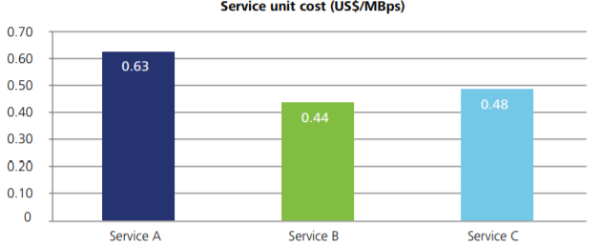

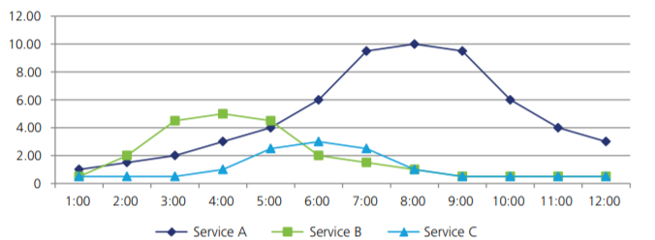

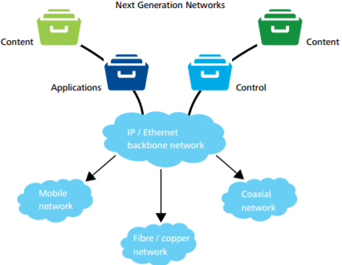

***Fully Allocated Cost(FAC)****:*

The Cost of the party providing such Service and/or Additional Service, including all amounts for compensation and benefits (including any incentive amounts awarded pertaining to the Services and/or Additional services provided hereunder), technology expenses, occupancy, office and equipment expense, and third-party payments incurred in connection with the provision of such Service or Additional Service, plus applicable mark up which shall initially be **15%** and which may be adjusted from time to time as agreed to by the parties, including any Taxes payable as a result of performance of such Service or Additional Service.

All costs are considered and allocated to all services provided by the network; commonly used in conjunction with a top-down model. Resulting costs for services will be the highest possible and provide an indication of the cost ceiling.

**Margin pressure** and the focus on performance management has in turn increased the importance of a correct, cost allocation to make well informed decisions about product portfolio changes.

***Long Run Incremental Cost(LRIC)***:

LRIC, only incremental costs or service-specific fixed costs are allocated to services. If joint and common costs are allocated through mark-ups, the LRIC method will begin to resemble FAC.

Resulting costs for services will be minimal and provide an indication of the cost floor.

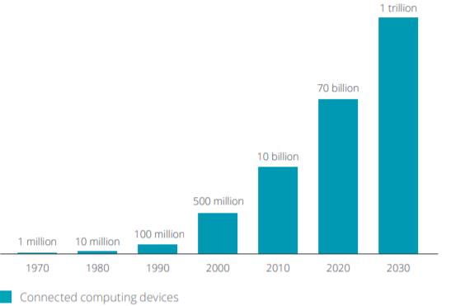

Due to continual technological changes in transmission and receiving technology, Shockwave re-writes approximately 20% of the software's algorithm code on an annual basis. Long-term growth is expected to equal 2% to 3%.

The internal rate of return of 12% reflects a market based an after-tax cost of debt between 5%-6% and a cost of equity between 15% to 16%.

Mostly relating to differences between FAC and LRIC, the inclusion or exclusion of certain costs and treatment of common costs, with their specific uses dictated by circumstances.

***Embedded Cost****:*

*Embedded Cost only includes the directly allocated cost of a service, not including any share of common cost.*

*This Reflects the incremental cost of providing the service on top of all other services.*

*Overall, there is a significant increase in the respondents using outsourcing to enhance* ***Merger*** *and* ***Acquisitions***

*Efforts from 45% in 2016 to 68% 2019. Reduce the need for transition service agreements, increase the speed with which acquired organizations are integrated, lower the operating cost.*

***SUBMITTED BY:***

***MIRTUNJAY KUMAR TYAGI***

***19/BMS/0051***

***REFERENCES:***

* <https://www2.deloitte.com/content/dam/Deloitte/sg/Documents/technology-media-telecommunications/sea-tmt-costing-methodology-next-generation-networks.pdf>
* <https://www2.deloitte.com/content/dam/Deloitte/my/Documents/tax/my-tax-gst-chat-july>
* <https://www2.deloitte.com/ch/en/pages/finance/solutions/cost-allocation>
* <https://www.ofcom.org.uk/__data/assets/pdf_file/0022/55327/deloitte.pdf>
* <https://www.oecd.org/tax/transfer-pricing/47426115>
* <https://www2.deloitte.com/content/dam/Deloitte/ca/Documents/finance/ca-en-FA-cost-reduction->
* <https://www.slideshare.net/DeloitteUS/the-2018-deloitte-global-outsourcing-survey>

***THANK YOU***